IMMIGRATION CHARTER
Ancestral REGIONS:
NORTH AMERICA, EUROPE, EURASIA, SOUTH AMERICA, AFRICA, MIDDLE EAST, ASIA, ORIENT, AUSTRALASIA and PACIFIC ISLANDS.
For the sake of GLOBAL/REGIONAL & National/Social stability & harmony always remain/stay to live where at all possible within your ancestral country or at least within a country within your ancestral REGION. People from different ancestral REGIONS are usually just too psychologically varied to properly mix & intermingle. This is simply a statement of fact and nothing more.
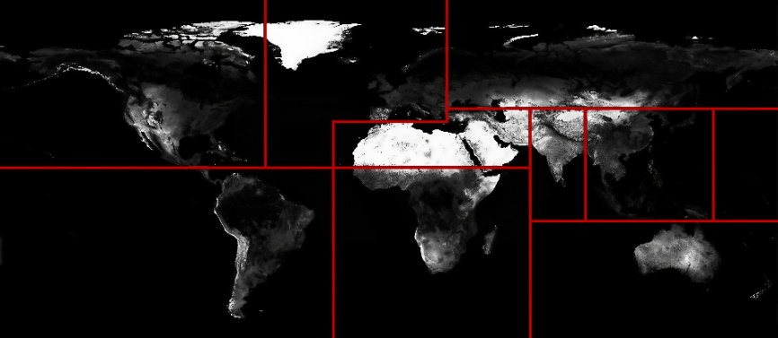

Of course people should & must be allowed to properly go to live in another country if/when absolutely needed. Also people should & must be permitted to leave a seriously desperate country and go to a neighbouring less desperate country within the same ancestral REGION without having the correct paperwork or authority But never under any circumstance any further and in particular never to any country within another ancestral region.
Anyone who improperly enters a country within a non ancestral region i.e. an ancestral region they have no significant historical/genetic link too or overstays in a country within a non ancestral region i.e. an ancestral region they have no significant historical/genetic link too should & must be immediately detained until they either agree to leave the country or they can be deported. Anyone who has improperly entered a country within a non ancestral REGION i.e. an ancestral region they have no significant historical/genetic link too or overstayed in a country within a non ancestral REGION i.e. an ancestral region they have no significant historical/genetic link too since 0.00am 1st January 2013 should & must be detained along with anyone in that country due/because of them until they either agree to leave the country or they can be deported. ANY funds/possessions acquired by any of them while improperly within the country should & must be confiscated after detention and before deportation.
People should & must be encouraged to remain within their respective ancestral countries or at least a country within their ancestral REGION. This is to avoid potentially serious mass immigration problems on a GLOBAL/REGIONAL scale and also Potentially serious interracial problems on a National/Social level. Plus of course ancient national identities should & must be protected, maintain and conserved. the only way to ensure all of this is by introducing relatively reasonable Restrictions & Limitations on all non ancestral’s within any country.
Just because someone is born in a country does not give them any right to ancestral status within that country. The only way anyone can have ancestral status is if they have a direct blood relative born and permanently living within the main territory of the country or another country within the same ancestral region between 1801 - 1900.
Never in any country should non ancestral’s i.e. anyone without a direct blood relative born and permanently living within the main territory of the country or another country within the same ancestral REGION between 1801 – 1900 have aid contributions in relation to any state provision.
Aid contributions must only be the sole preserve of ancestral’s with a direct blood relative born and permanently living within the main territory of the country or another country within the same ancestral region between 1801 - 1900.
ALL those from another ancestral regional descent without a 19th century direct genetic link to the country or another country within the same ancestral REGION should & must pay in full all medical & educational needs for themselves and any family member.
Never in any country should non ancestral’s i.e. anyone without a direct blood relative born and permanently living within the main territory of the country or another country within the same ancestral REGION between 1801 – 1900 have voting abilities in any poll, referendum or election.
Voting abilities must only be the sole preserve of ancestral’s with a direct blood relative born and permanently living within the main territory of the country or another country within the same ancestral region between 1801 - 1900.
Never in any country should non ancestral’s i.e. anyone without a direct blood relative born and permanently living within the main territory of the country between 1801 – 1900 hold citizenship and/or passport of that country.
Nationality status’s must only be the sole preserve of ancestral’s with a direct blood relative born and permanently living within the main territory of the country between 1801 - 1900.
Any non ancestral already having citizenship and/or holding a passport to relinquish any receipt of any extra privilege due to that citizenship and/or hand over any related passport within the space of one month.
Never in any country should non ancestral’s i.e. anyone without a direct blood relative born and permanently living within the main territory of the country or another country within the same ancestral REGION go over 10% in any urban area or any location whatsoever within the country.
Location majorities must only be the sole preserve of ancestral’s with a direct blood relative born and permanently living within the main territory of the country or another country within the same ancestral region between 1801 - 1900.
Where non ancestral’s go above 10% in any location they should & must be obliged to move to another location with less than 10% non ancestral’s on a last-in first-out basis within 3 months are be forcibly moved (except in tourist designated areas). Non ancestral’s should & must never to go over 10% in any larger town or city or any school/classroom, GP surgery, hospital ward, dentistry or any social/public amenity/facility.
Never in any country should non ancestral’s i.e. anyone without a direct blood relative born and permanently living within the main territory of the country or another country within the same ancestral REGION openly publically display other ancestral REGION religious/cultural clothing or regalia.
Public exhibition must only be the sole preserve of ancestral’s with a direct blood relative born and permanently living within the main territory of the country or another country within the same ancestral region between 1801 - 1900.
Where there is an absolute need to wear some religious/cultural garment/item of another religion/culture from another ancestral REGION that alternative garment/item should & must be concealed/covered. Also no publically visible alternative religious/cultural or other ancestral REGION flags, emblems or symbols should & must not be permitted on any structure or in any window. Verbal warnings & fines will be introduced for first and secondary infractions and possible imprisonment/deportation for serious repeat infractions. All schools, colleges and universities both private & public anywhere within any country should & must be solely based around the established ancient religion/culture of the country and they should & must only teach & promote that particular religion/culture and under no any other.
Never in any country should non ancestral’s i.e. anyone without a direct blood relative born and permanently living within the main territory of the country or another country within the same ancestral REGION hold any governmental or local council position, any senior role, any role dealing directly with the general public (except in other ancestral REGION based establishments) or any part in any team/competition within the country and in particular any national related team/competition.
Specialised roles must only be the sole preserve of ancestral’s with a direct blood relative born and permanently living within the main territory of the country or another country within the same ancestral region between 1801 - 1900.
All non ancestral’s already in any team or involved in any competition either nationally or internationally in any way representing the country should & must immediately leave that team and/or event.
Never in any country should non ancestral’s i.e. anyone without a direct blood relative born and permanently living within the main territory of the country or another country within the same ancestral REGION be permitted to gather in groups more than five, hold demonstrations of any kind, attend national & local ancestral based events of any kind or hold any public events of any kind.
Public events must only be the sole preserve of ancestral’s with a direct blood relative born and permanently living within the main territory of the country or another country within the same ancestral region between 1801 - 1900.
Never in any country should non ancestral’s i.e. anyone without a direct blood relative born and permanently living within the main territory of the country or another country within the same ancestral REGION be permitted in exclusively ancestral based colleges & universities, B&B’s, hotels, spas, gyms, swimming pools, cafes, restaurants, bars, clubs etc.
Social venues must generally only be the sole preserve of ancestral’s with a direct blood relative born and permanently living within the main territory of the country or another country within the same ancestral region between 1801 - 1900.
90&% of all public enclosed spaces in any country should & must have a strict only ancestral policy and 10% a solely non ancestral policy. Ancestral and non ancestral identity cards should & must be issued. In localities up to 100,000 residents one of each catagory of public amenity of solely non ancestral status will be permitted, 200,000 two, 300,000 three and so on.
Never in any country should non ancestral’s i.e. anyone without a direct blood relative born and permanently living within the main territory of the country or another country within the same ancestral REGION be permitted on nationally based broadcasting channel programs or ads or to appear on any stage within the country (except for non resident visiting non ancestral’s).
Media appearances must generally only be the sole preserve of ancestral’s with a direct blood relative born and permanently living within the main territory of the country or another country within the same ancestral region between 1801 - 1900.
Where someone with another ancestral REGION characteristics is required in any production then someone with those particular ancestral REGION characteristics plus a direct genetic link to the country or a country within the same ancestral REGION within the country or a visiting non resident non ancestral should & must be found.
Never in any country should non ancestral’s i.e. anyone without a direct blood relative born and permanently living within the main territory of the country or another country within the same ancestral REGION be permitted to live in any town, village, hamlet within the country, own any land within the country.
Country living must only be the sole preserve of ancestral’s with a direct blood relative born and permanently living within the main territory of the country or another country within the same ancestral region between 1801 - 1900.
Non ancestral’s are better concentrated in the more larger towns and in particular cities within any country and it is best they avoid where at all possible going to smaller towns, villages or hamlets even to visit. Where a non ancestral already owns a rural property or land they will need to sell that property or land to an ancestral within six months or have that property or land confiscated. Where a non ancestral rents a rural property or land they will need to vacate that property or land in favour of an ancestral within three months or be evicted.
A full and complete investigation into anyone from another ancestral regional descent without a 19th century direct genetic link to the country or another country within the same ancestral REGION who has purchased any property within the country since 0.00am 1st January 2013 as to where the funds have come from for that purchase and where there is any significant doubt about the origin of those funds the property should & must be confiscated. Also the local authorities to deal as swiftly & promptly as possible with in particular any non ancestral annoying or disturbing any ancestral person anywhere within the country in any way causing a general extra nuisance within any community or neighbourhood.

BLACKLEAFARCADE.COM/GLOBAL.MIGRATION

